**BUG REPORT OF KNOWORK Web Application**

**Name:** Warish Kumar

**Device:** Vivo y75 5G

**Web Address:** <https://operator.knowork.xyz>

**Module:** Register, Login

**Bug Id: 1**

**Module Name:** Register

**Bug Description:** Keyboard overlap while typing in any field & screen is not scrollable.

**Steps:** 1) Open Register Page 2) Write any think in any field and try to see register button.

**Expected Result:** It should scrollable.

**Screen Orientation:** Portrait

**Bug Images:**

**Bug Id: 2**

**Module Name:** Register

**Bug Description:** Colour of App Terms & Privacy Policy is not proper.

**Steps:** 1) Open Register Page.

**Expected Result:** It should be highlighted.

**Screen Orientation:** Portrait

**Bug Images:**

**Bug Id: 3**

**Module Name:** Register

**Bug Description:** Eye icon is not available in Password and Password Confirmation Page.

**Steps:**

**Expected Result:** Eye icon should be there for show & hide password.

**Screen Orientation:** Portrait

**Bug Images:**

**Bug Id: 4**

**Module Name:** Register

**Bug Description:** Whole Register page is not fit in screen.

**Steps:**

**Expected Result:** All field should be visible.

**Screen Orientation:** Landscape

**Bug Images:**

**Bug Id: 5**

**Module Name:** Register

**Bug Description:** No scroll bar is there.

**Steps:**

**Expected Result:** There should be scroll bar in form, that helps us to access of hidden component.

**Screen Orientation:** Landscape

**Bug Images:**

**Bug Id: 6**

**Module Name:** Login

**Bug Description:** Eye icon is not available in Password field

**Steps:**

**Expected Result:** Eye icon should be there in password field.

**Screen Orientation:** Portrait

**Bug Images:**

**Bug Id: 7**

**Module Name:** Login

**Bug Description:** Can’t be scrolled to click on Register button when keyboard is appear.

**Steps:**

**Expected Result:** It should scroll when any component is overlapped by keyboard.

**Screen Orientation:** Portrait

**Bug Images:**

**Bug Id: 8**

**Module Name:** Login

**Bug Description:** Login page is not fitted in Landscape mode.

**Steps:**

**Expected Result:** All component should be visible in all screen orientation.

**Screen Orientation:** Landscape

**Bug Images:**

**Bug Id: 9**

**Module Name:** Login

**Bug Description:** Eye icon is not available in landscape mode.

**Steps:**

**Expected Result:** Eye icon should be there in password field.

**Screen Orientation:** Landscape

**Bug Images:**

**Bug Id: 10**

**Module Name:** Login

**Bug Description:** Scroll bar is not available.

**Steps:**

**Expected Result:** When all components not fitted in screen, then it should be scroll bar to access other component of page.

**Screen Orientation:** Landscape

**Bug Images:**

**Bug Id: 11**

**Module Name:** Static Page

**Bug Description:** Static page is not fitted properly.

**Steps:**

**Expected Result:** All components should be visible in screen.

**Screen Orientation:** Portrait

**Bug Images:**

**Bug Id: 12**

**Module Name:** Static Page

**Bug Description:** For go further, there is not button is available.

**Steps:**

**Expected Result:** For create space, button should be visible there.

**Screen Orientation:** Portrait

**Bug Images:**

**Bug Id: 13**

**Module Name:** Create Space

**Bug Description:** When upload image of maximum height then send button is not visible.

**Steps:**

**Expected Result:** Send button should be visible in all condition.

**Screen Orientation:** Portrait

**Bug Images:**

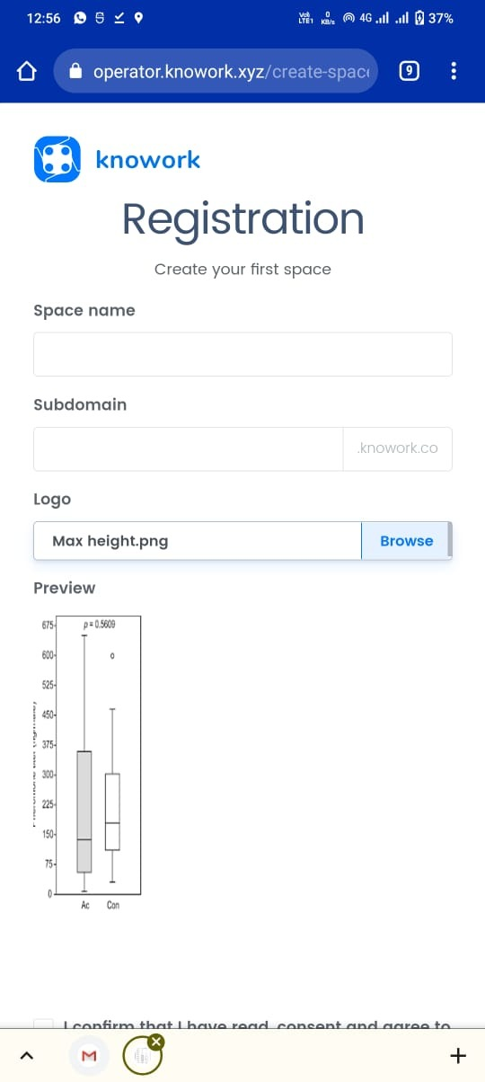

**Bug Id: 14**

**Module Name:** Create Space

**Bug Description:** Create Space page is not properly fitted in Landscape mode.

**Steps:**

**Expected Result:** Create Space page should be fitted in all mode.

**Screen Orientation:** Landscape

**Bug Images:**

